Mini Project
on
“AI based Crowd Density & Flow Tracking”
Submitted in partial fulfillment of the requirements for the award of the degree of
BACHELOR OF TECHNOLOGY
in
ELECTRONICS AND COMMUNICATION ENGINEERING
by
Anshu Bonagiri 23WH1A0461
A.Sathya Sri 23WH1A0434
Keerthana Malluri 23WH1A0459
G.Triveni 23WH1A0408
under the guidance of
Dr.J.Naga Vishnu Vardhan
Professor, ECE and Dean Academics

Department of Electronics and Communication Engineering
BVRIT HYDERABAD College of Engineering for Women
(UGC Autonomous Institution | Approved by AICTE | Affiliated to JNTUH)
(NAAC Accredited – A Grade | NBA Accredited B. Tech. (EEE, ECE and CSE) )
Bachupally, Hyderabad – 500090
2025-26
DECLARATION

We hereby declare that the work described in this report, entitled “AI based Crowd Density & Flow Tracking” which is being submitted by us in partial fulfilment for the award of the degree of Bachelor of Technology in the Department of Electronics and Communication Engineering at BVRIT HYDERABAD College of Engineering for Women (Autonomous), affiliated to Jawaharlal Nehru Technological University Hyderabad, Kukatpally, Hyderabad – 500090 is the result of original work carried out by us under the guidance of Dr.J.Naga Vishnu Vardhan.
This work has not been submitted for any Degree/Diploma of this or any other institute/university to the best of our knowledge and belief.

Place: Hyderabad
Date:
Names and signatures of the students
Anshu Bonagiri 23WH1A0461
A.Sathya Sri 23WH1A0434
Keerthana Malluri 23WH1A0459
G.Triveni 23WH1A0408

Department of Electronics and Communication Engineering
BVRIT HYDERABAD College of Engineering for Women
(UGC Autonomous Institution | Approved by AICTE | Affiliated to JNTUH)
(NAAC Accredited – A Grade | NBA Accredited B. Tech. (EEE, ECE and CSE) )
Bachupally, Hyderabad – 500090


Certificate

This is to certify that the major/mini project report, entitled “AI based Crowd Density & Flow Tracking” is a record of bonafide work carried out by
Anshu Bonagiri (23WH1A0461), A.Sathya Sri (23WH1A0434),
Keerthana Malluri (23WH1A0459), G.Triveni (23WH1A0408) in partial fulfilment for the award of the degree of Bachelor of Technology in the department of Electronics and Communication Engineering at BVRIT HYDERABAD College of Engineering for Women (Autonomous), affiliated to Jawaharlal Nehru Technological University Hyderabad, Kukatpally, Hyderabad – 500090.

Supervisor Head of the Department

External Examiner

ACKNOWLEDGMENT
The satisfaction that accompanies the successful completion of the task would be incomplete without the mention of the people who made it possible.
We wish to express our deep sense of gratitude to our guide Dr. J. Naga Vishnu Vardhan, Professor, ECE and Dean Academics, Department of Electronics and Communication Engineering, BVRIT HYDERABAD College of Engineering for Women (Autonomous), for his able guidance and suggestions, which helped us in completing this project work on time.
We would like to thank Dr. Nagesh Deevi, Associate Professor and Head, Department of Electronics and Communication Engineering for his guidance, support and encouragement.
We express our gratitude towards our honorable Principal, Dr. K V N Sunitha and the management for providing all the facilities.
We also thank all the faculty and non-teaching staff members of the Electronics and Communication Engineering department, who supported us directly or indirectly in the successful completion of this project work.
Finally, we thank all our friends and family members for their continuous support and help.

Names of the students
Anshu Bonagiri
A.Sathya Sri
Keerthana Malluri
G.Triveni

ABSTRACT
The rapid advancement of urban environments and the increasing frequency of large-scale public gatherings have necessitated more sophisticated methods for crowd management. Traditional monitoring techniques, often reliant on manual observation or legacy surveillance systems, frequently fail to provide the real-time insights required for proactive safety intervention. This report details the design and implementation of an AI-Based Crowd Density and Flow Tracker, a system engineered to address these challenges through edge-based computational intelligence. Utilizing the Raspberry Pi 5 as the primary computing platform, the system integrates a USB camera to capture live video feeds, which are processed locally using the YOLOv8 (You Only Look Once) object detection framework. By shifting the computational burden to the edge, the system ensures low-latency detection while maintaining data privacy. The analytical output, comprising individual counts and localized density metrics, is communicated via an MQTT-based messaging architecture to a Flask backend. A centralized Streamlit dashboard provides users with real-time visualizations and historical data analysis, enabling data-driven decision-making. Performance evaluations indicate that with INT8 quantization, the system achieves efficient frame rates suitable for real-time monitoring of pedestrian flow in dynamic public spaces.

Contents
S. No | Topic | Page No.
1. | Introduction  1.1 Introduction to Crowd Monitoring Systems  1.2 Challenges in Crowd Analysis | 1
2. | Literature Survey | 2
3. | Methodology  3.1 Detection and Tracking  3.2 Density and Cluster Analysis  3.3 Flow and Movement Analysis  3.4 Alert and Visualization System | 3-5
4. | 4. Implementation  4.1 Hardware  4.2 Hardware Setup  4.2 Software  4.3 Modules | 6-13
5. | Results | 14-19
6. | Applications | 20-21
7. | Future Enhancements | 22-23
8. | Conclusion | 24
9. | References | 25

LIST OF FIGURES AND TABLES

S. No | Title | Fig No.
1. | Block Diagram | 1
2. | Flowchart | 2
3. | Raspberry Pi 5 | 3
4. | Webcam | 4
5. | Working Setup | 5
6. | Raspberry 5 Connections | 6
7. | Detector Outputs | 7-8
8. | Server Outputs  -Flask Execution  -Streamlit Dashboard Deployment | 9-10
9. | Dashboard | 11
10. | Results  -Low Density  Medium Density  -High Density with Alert  -Real-time dashboard Integration showing  -Entry/Exit Statistics, and Zone-wise Distribution | 12-16

1. Introduction
Crowd monitoring systems have become increasingly important in ensuring safety and efficient management of people in public and institutional environments. These systems utilize computer vision and artificial intelligence to detect, track, and analyze individuals in real time, providing valuable insights such as crowd density, movement patterns, and flow direction. Unlike traditional surveillance methods that only offer video feeds, modern crowd monitoring systems enable automated analysis, helping authorities take timely decisions to prevent overcrowding and maintain order. The integration of edge devices like Raspberry Pi further enhances these systems by enabling real-time processing with low cost and improved data privacy.

1.1 Introduction to Crowd Monitoring Systems
Crowd monitoring systems are intelligent solutions designed to observe and analyze human activity in a given area using cameras and AI-based algorithms. These systems detect individuals, count the number of people present, and evaluate crowd density levels such as low, medium, or high. Advanced systems also track movement patterns, identify clusters, and analyze entry and exit flow. Such capabilities are widely used in applications like smart surveillance, event management, transportation hubs, and campus monitoring to enhance safety and operational efficiency.

1.2 Challenges in Crowd Analysis
Despite technological advancements, crowd analysis faces several challenges. Occlusion occurs when individuals overlap, making detection difficult. Variations in lighting conditions can affect detection accuracy. Real-time processing is challenging due to limited computational resources, especially on edge devices like Raspberry Pi. Additionally, maintaining consistent tracking of individuals across frames can be difficult, leading to inaccuracies in counting and flow analysis. These challenges highlight the need for efficient algorithms and optimized system design.

2. Literature Review
Crowd monitoring and analysis have gained significant attention in recent years due to the increasing need for safety and efficient management in public spaces. Traditional surveillance systems primarily rely on CCTV cameras, which provide continuous video streams but lack automated analysis capabilities. These systems depend heavily on human monitoring, making them inefficient and prone to errors, especially in crowded environments.
With advancements in artificial intelligence, computer vision-based approaches have been developed to automate crowd analysis. Deep learning models such as YOLO (You Only Look Once) and SSD (Single Shot Detector) have been widely used for real-time human detection due to their high accuracy and speed. These models enable systems to detect and count individuals in dynamic environments, forming the foundation for crowd density estimation.
In addition to detection, tracking algorithms play a crucial role in analysing movement patterns. Techniques such as DeepSORT and centroid-based tracking help maintain consistent identities of individuals across frames, enabling accurate counting, entry/exit detection, and flow analysis. These methods improve the reliability of crowd monitoring systems compared to traditional frame-by-frame detection.
Recent research also focuses on deploying these systems on edge devices like Raspberry Pi to achieve real-time processing with low latency and enhanced data privacy. Edge-based systems reduce dependency on cloud infrastructure and are more suitable for applications requiring immediate response. Furthermore, the integration of dashboards and IoT-based communication protocols allows real-time visualization and remote monitoring of crowd data.
Overall, existing studies highlight the transition from manual surveillance to intelligent, automated systems using AI and edge computing. However, challenges such as occlusion, lighting variations, and computational limitations still exist, motivating the development of efficient and optimized solutions like the proposed AI-based crowd density and flow tracking system.
3. Methodology
The methodology encompasses the selection of hardware components, deep learning pipeline design, and communication middleware configuration to achieve efficient real-time crowd monitoring on an edge device.
3.1 Detection and Tracking
The system is centered on the Raspberry Pi 5, which utilizes a quad-core Cortex-A76 CPU for performing local inference. A high-definition USB camera is connected via USB 3.0 to capture real-time video frames with high data transfer rates. These frames are processed using the YOLOv8n model for human detection, and individuals are tracked across frames to maintain continuity in counting and movement analysis.
3.2 Density and Cluster Analysis
To achieve real-time performance on the Raspberry Pi, the YOLOv8n model is optimized by exporting it to ONNX format and applying INT8 quantization. This reduces computational complexity and improves processing speed. Based on the detected individuals, the system calculates crowd density (low, medium, high) and identifies clusters by grouping nearby people.
3.3 Flow and Movement Analysis
The system analyses movement by tracking the positions of individuals across frames. Entry and exit counts are calculated using virtual boundary lines, and the overall flow direction is determined by observing movement patterns, such as unidirectional or mixed flow.
3.4 Alert and Visualization System
For efficient data communication, the system uses the MQTT protocol with a public HiveMQ broker instead of a local server. This allows lightweight and asynchronous transmission of data over the internet. Data is published using Quality of Service (QoS) level 1, ensuring reliable message delivery even in case of temporary network issues. The processed information is then visualized on a Streamlit dashboard, which displays real-time crowd statistics such as people count, density, entry, exit, and flow direction, along with alerts when the crowd density exceeds a predefined threshold.
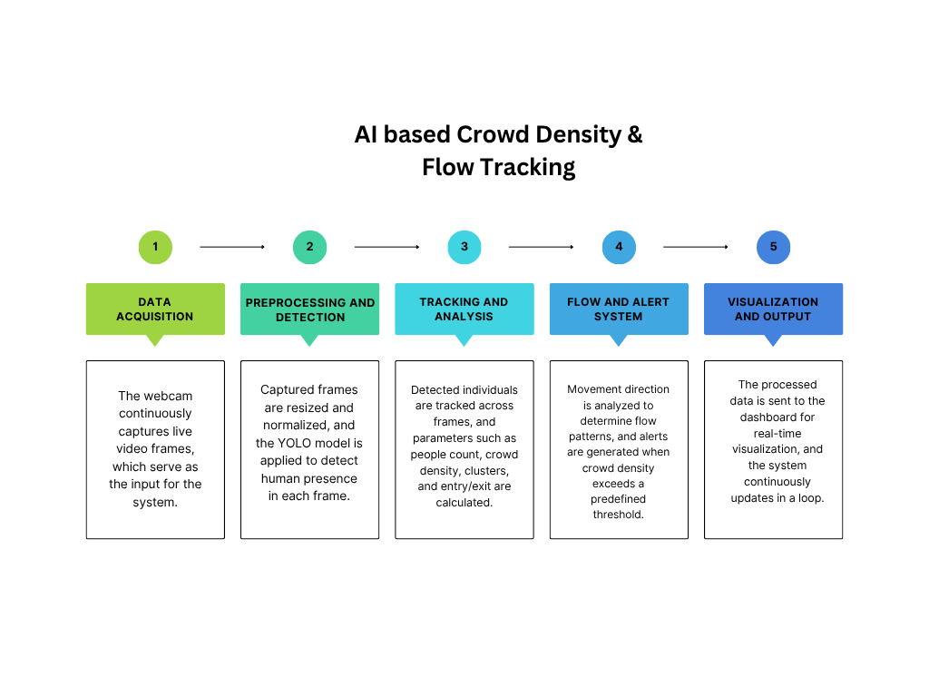
Fig.1: Block Diagram
The diagram shows the workflow of the AI-based crowd monitoring system in five stages. First, data acquisition captures live video from the webcam. Next, preprocessing and detection prepares the frames and uses the YOLO model to detect people. Then, tracking and analysis follows individuals across frames to compute metrics like people count, density, clusters, and entry/exit. After that, the flow and alert system analyze movement direction and triggers alerts if crowd density is high. Finally, visualization and output display the processed data on a dashboard, continuously updating in real time.
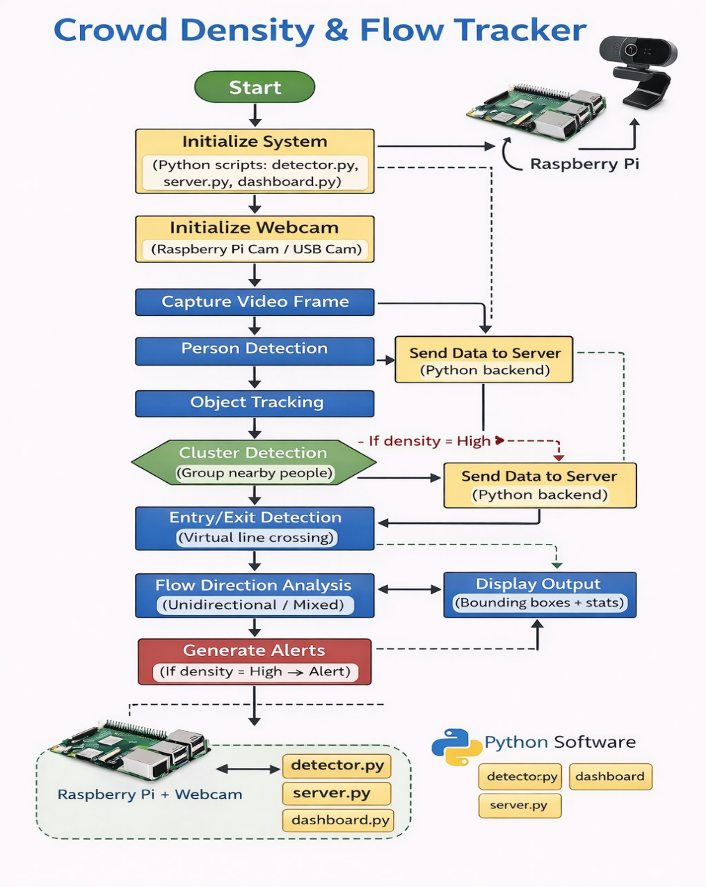
Fig.2: Flowchart
This flowchart represents the working of the AI-based crowd density and flow tracking system. The process starts by initializing the system and webcam on the Raspberry Pi, followed by continuous video frame capture. Each frame is processed to detect people using the YOLO model, and object tracking assigns IDs to individuals. The system then performs cluster detection to identify grouped people and calculates entry and exit counts using a virtual line. Movement is analyzed to determine flow direction (unidirectional or mixed). If the crowd density becomes high, an alert is generated. All computed data is sent to the server and displayed as bounding boxes and statistics on the screen and dashboard. The entire process runs continuously for real-time monitoring.
4. Implementation
4.1 Hardware
The hardware setup consists of a Raspberry Pi 5 and a USB webcam. The webcam captures live video frames, which are processed locally on the Raspberry Pi. The device performs real-time inference using the optimized YOLOv8 model and handles all computations including detection, tracking, and analytics. The compact hardware setup ensures portability and cost efficiency while maintaining real-time performance.
Raspberry Pi 5:
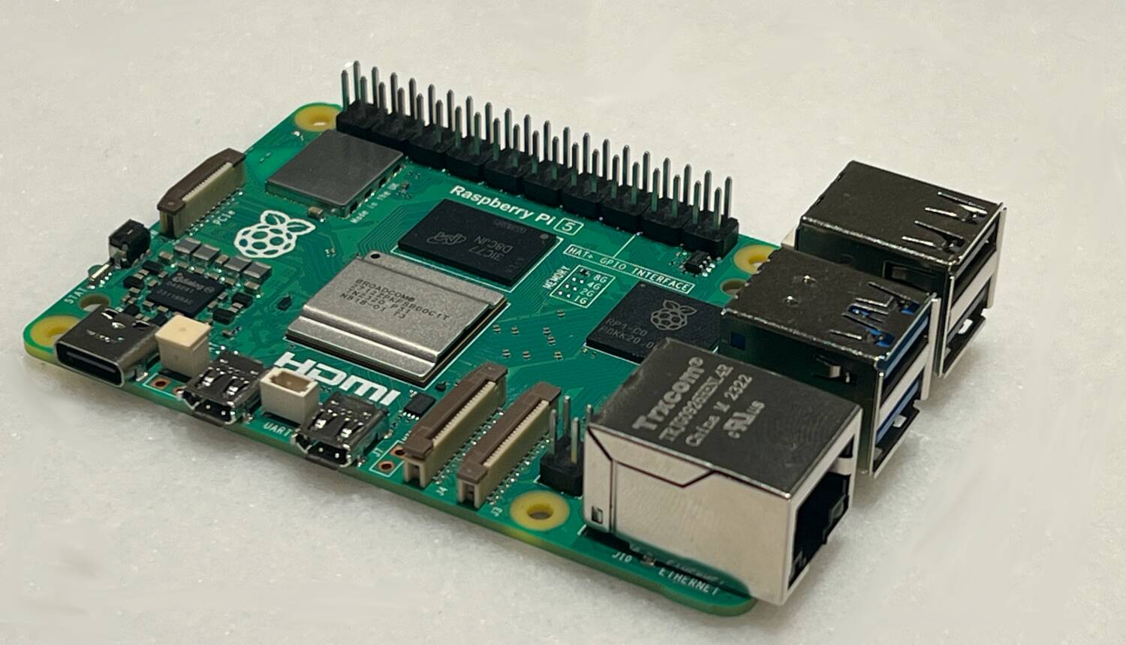
Fig.3: Raspberry Pi 5
The Raspberry Pi 5 is a compact single-board computer designed for high-performance embedded and edge computing applications. It is powered by a quad-core ARM Cortex-A76 processor, which provides significantly improved processing speed, making it suitable for real-time tasks such as video processing and AI-based crowd analysis. The board supports up to 8 GB of LPDDR4X RAM, enabling efficient multitasking and handling of compute-intensive operations like object detection and tracking.
As shown in the figure, the Raspberry Pi 5 includes multiple connectivity options such as USB 3.0 ports for high-speed data transfer, which are essential for connecting peripherals like webcams. It also features dual micro-HDMI ports for display output, a Gigabit Ethernet port for wired networking, and onboard Wi-Fi and Bluetooth for wireless communication. The GPIO (General Purpose Input/Output) pins allow interfacing with additional sensors and hardware components if required.
The board operates on a Linux-based operating system (Raspberry Pi OS) and supports programming in Python along with libraries such as OpenCV and deep learning frameworks. In this project, the Raspberry Pi 5 functions as the central processing unit, capturing video input from the webcam, performing real-time person detection and tracking, and sending processed data to the server and dashboard. Its compact size, low power consumption, and strong computational capability make it an ideal choice for edge-based intelligent surveillance systems.
Webcam:
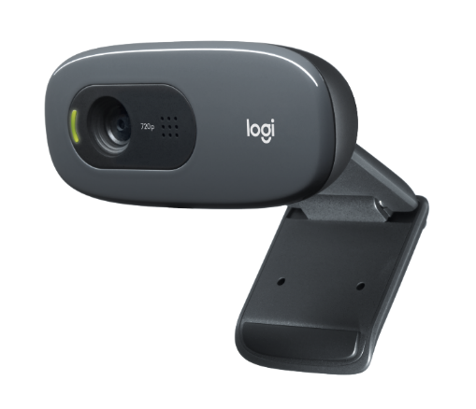
Fig.4: Webcam
The webcam used in this project is a compact USB camera designed for real-time video capture and computer vision applications. It supports a resolution of 720p HD, which provides sufficient clarity for accurate human detection and tracking while maintaining low computational load on the Raspberry Pi. The camera is equipped with an integrated lens and built-in microphone, along with an LED indicator to show active operation.
The webcam connects to the Raspberry Pi via a USB interface, ensuring easy plug-and-play functionality without requiring additional drivers. It delivers continuous video frames that are processed by the detection algorithm for identifying people, tracking movement, and analysing crowd density. The adjustable mounting clip allows flexible positioning on monitors or flat surfaces, making it suitable for indoor monitoring setups.
In this system, the webcam acts as the primary input device, capturing live video data that is used for real-time crowd detection and flow analysis. Its reliability, compatibility, and adequate resolution make it an effective and cost-efficient choice for edge-based surveillance applications.
4.2 Hardware Setup
The hardware setup of the proposed system is designed to enable real-time crowd monitoring using a compact and efficient edge device. The system is built around the Raspberry Pi 5, which acts as the central processing unit. It is connected with essential peripherals including a USB webcam for video input, a monitor for display output, and keyboard and mouse for user interaction. A stable power supply is provided to ensure continuous operation. This setup allows the system to capture live video, process it locally, and display results in real time without requiring high-end hardware.
Hardware Components Used:
- Raspberry Pi 5
- USB Webcam
- Monitor (Display)
- Keyboard
- Mouse
- Power Supply (USB-C)
- HDMI Cable for display connection
Working Setup Description:
The Raspberry Pi is powered using a USB-C power adapter and connected to a monitor via an HDMI cable for visual output. A keyboard and mouse are attached through USB ports to control and operate the system. The webcam is connected to the Raspberry Pi through a USB interface and positioned to capture live video frames. All components together form a complete embedded system capable of running Python-based detection and dashboard applications.

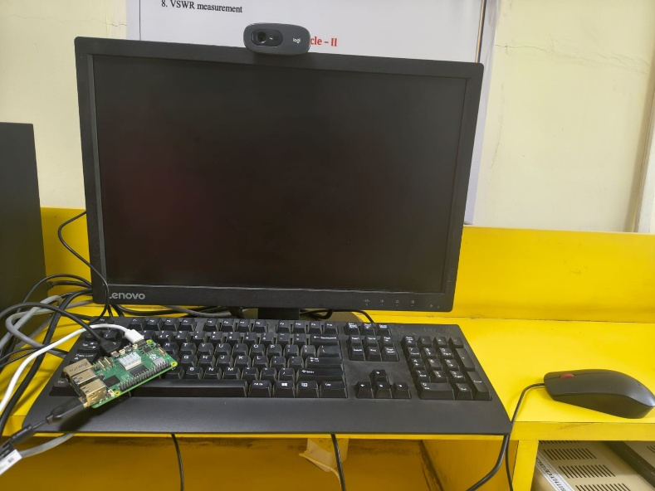
Fig.5: Complete Setup
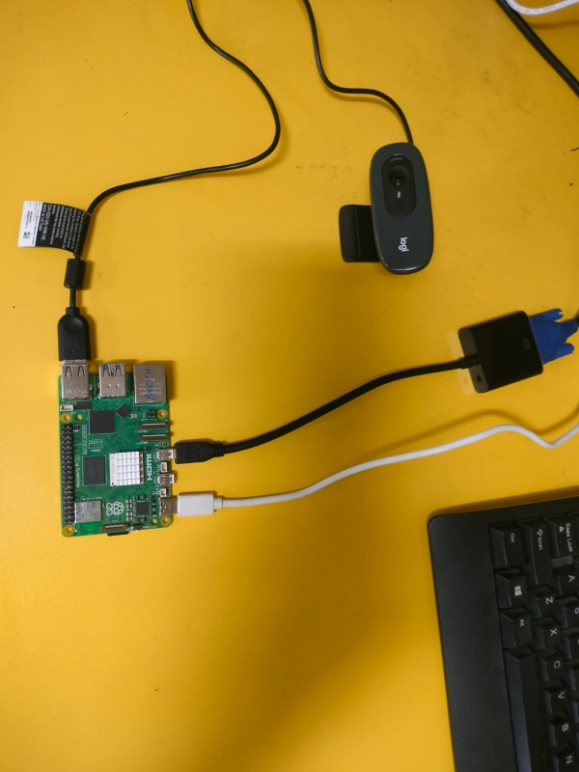
Fig.6: Raspberry 5 Connections
As shown in the figure, the Raspberry Pi is connected to a monitor, keyboard, and mouse for user interface and control. A USB webcam is mounted on the monitor to capture real-time video input. The Raspberry Pi receives power through a USB-C connection and processes the incoming video data. The processed output is then displayed on the monitor, demonstrating the complete working setup of the system.
4.3 Software
The system is implemented using Python with multiple libraries for computer vision, machine learning, and visualization. The YOLOv8 model (Ultralytics) is used for real-time person detection, while OpenCV handles video capture and frame processing. The system uses the requests library to send processed data to a backend server. A Streamlit-based dashboard is developed for real-time visualization of crowd statistics such as people count, density, entry, exit, and flow direction. Additional libraries like NumPy and Pandas are used for data handling and analysis.
4.4 Modules
The software architecture follows a modular, distributed design consisting of four primary components:
- Object Detection and Tracking
- Crowd Analytics and Spatial Processing
- Backend and Communication
- Web-Based Visualization
4.4.1 Object Detection and Tracking (detector.py)
The core vision module utilizes the YOLOv8n (You Only Look Once) model to perform high-speed inference on the video stream. To optimize performance on the Raspberry Pi 5, the image size is restricted to 320 pixels. The script captures frames from the webcam and passes them to the model’s tracking function (model.track), which assigns a unique, persistent ID to every person detected.
The system maintains a set of known_ids to manage counting logic. By comparing the IDs present in the current frame against the previous frame, it identifies "new" IDs to increment the entry counter and missing IDs to increment the exit counter. Each frame is then annotated with bounding boxes, confidence scores, and a status bar that changes colour (green, orange, or red) based on the density level returned by the analytics module.
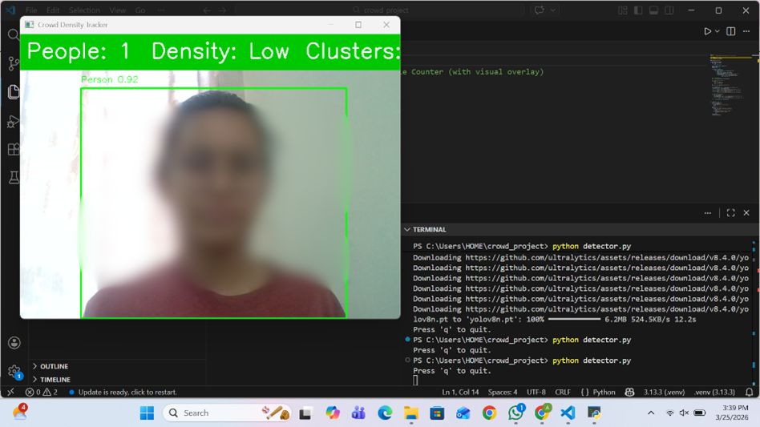
Fig.7: Single Person detected
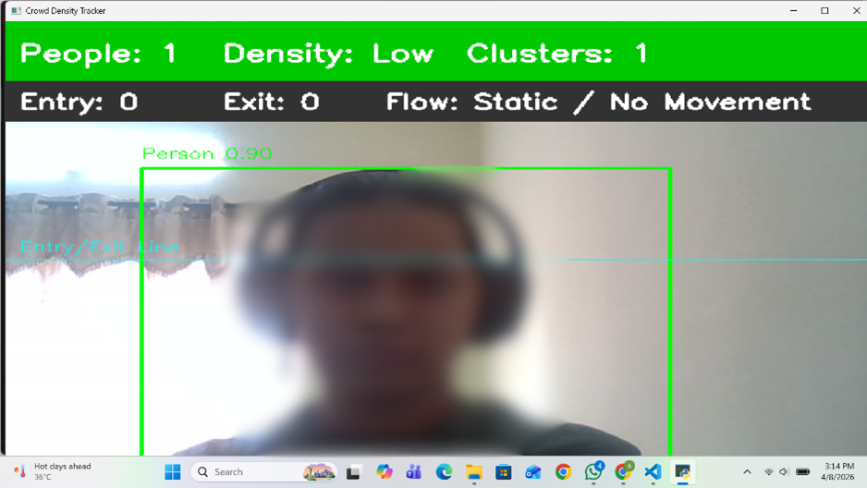
Fig.8: Low density with single cluster
4.4.2 Crowd Analytics and Spatial Processing (analytics.py)
This module serves as the computational engine that transforms raw bounding box coordinates into meaningful metrics.
Density & Level Classification: It calculates density by dividing the current person count by a predefined area (20.0 m²). The result is then categorized as "LOW", "MEDIUM", or "HIGH" based on threshold constants (LOW_MAX, MEDIUM_MAX).
Flow & Zone Monitoring: The frame is mathematically divided into three vertical segments (Zone A, B, and C). The script calculates the centroid of each bounding box which is used to a specific zone to provide a localized population breakdown.
Cluster Detection: It employs a distance-based clustering algorithm. By calculating the Euclidean distance between the centres of all detected individuals, it groups people into clusters if they are within 150 pixels of one another, which is vital for identifying social distancing violations or bottleneck formations.
4.4.3 Backend and Communication (server.py)
The system uses a Flask-based REST API to bridge the gap between the edge device and the end-user. The detection script sends a JSON payload containing counts, density levels, and zone data to the /crowd-data endpoint. Simultaneously, this module acts as an MQTT client, publishing these updates to a public HiveMQ broker (crowd/data). This dual-layer communication ensures that the data is available for both web-based requests and low-bandwidth IoT subscribers. If the population exceeds the ALERT_THRESHOLD, a high-priority alert message is immediately published to a dedicated alert topic.
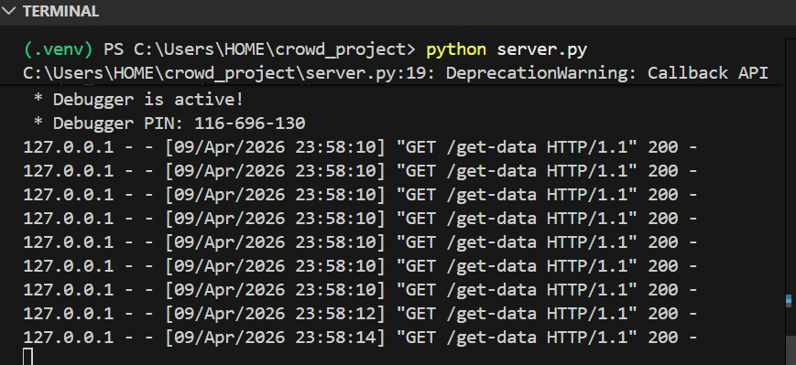
Fig.9: Flask Server Execution and Real-Time Data Requests
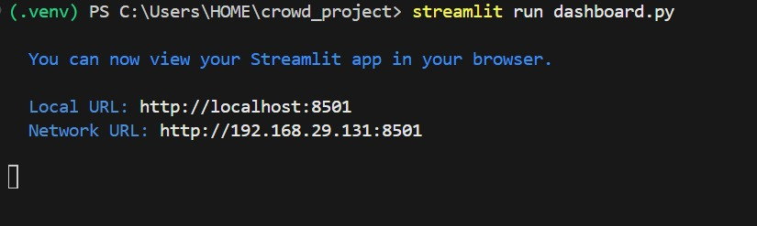
Fig.10: Streamlit Dashboard Deployment and Local Access
4.4.4 Web-Based Visualization (dashboard.py)
The final layer is a Streamlit dashboard that provides a high-level overview of the monitored site. It uses custom CSS to create a modern, high-contrast interface featuring dynamic "metric cards" for entry, exit, and density. The dashboard polls the Flask server every two seconds to update its state. It includes a Time-Series Graph that tracks the history of the last 20 readings, allowing administrators to observe trends in crowd growth. Additionally, it uses progress bars to represent the capacity of different zones and triggers visual "Alarm" banner if the backend signals a high-density state.
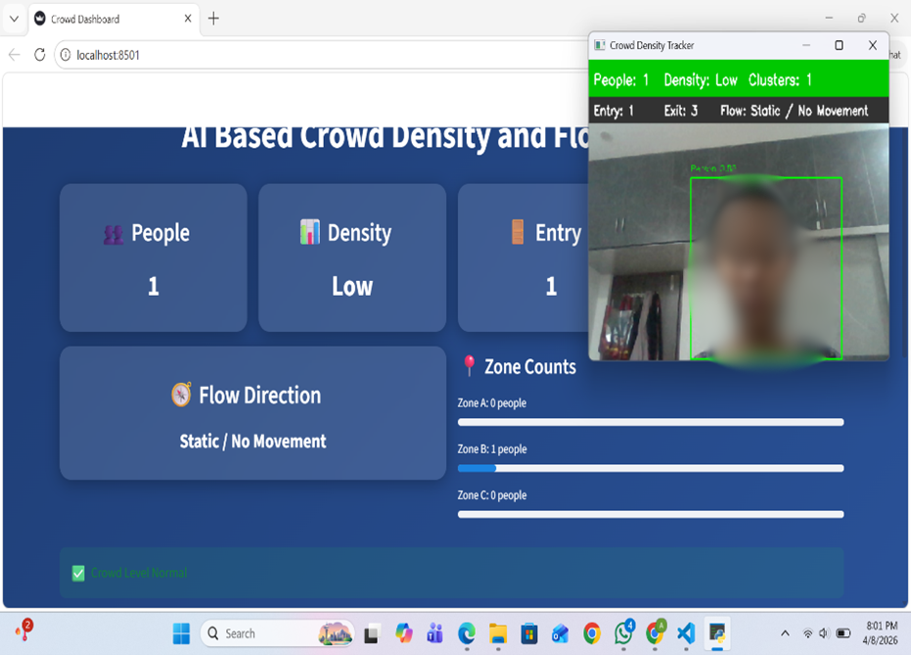
Fig.11: Real-Time Dashboard Visualization and Static Flow Detection

5. Results
The results of the proposed AI-Based Crowd Density and Flow Tracker demonstrate the system’s ability to accurately detect, analyse, and visualize crowd behaviour under different conditions. The system was tested in real-time using a webcam connected to the Raspberry Pi, and the outputs were observed for varying crowd sizes categorized as low, medium, and high-density levels.
For each scenario, the system successfully performed key functions including people detection, density classification, cluster identification, entry and exit counting, and flow direction analysis. In low and medium density conditions, the system maintained stable monitoring without triggering alerts, while in high-density situations, it effectively generated warnings indicating overcrowding. Additionally, all computed parameters were displayed on a live dashboard, providing clear visualization of crowd statistics and system status.
The crowd density is mainly categorized into three scenarios indicated by different colours which are:
- Low Density Scenario - Green
- Medium Density Scenario - Orange
- High Density Scenario with Alert - Red

Case 1: Low Desnity
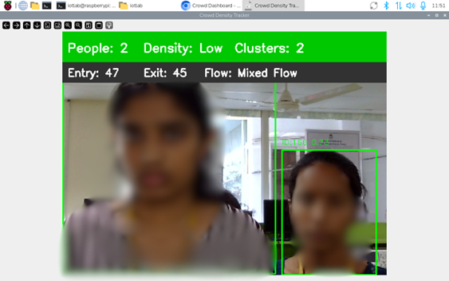
Fig.12: Low Density Scenario
- People Detected: 2
- Density Level: Low
- Clusters Identified: 2
- Entry Count: 47
- Exit Count: 45
- Flow Direction: Mixed Flow
- System Status: Normal (No overcrowding alert)
Inference:
The scene contains a small number of people with low density, distributed into two separate clusters. Entry and exit counts are nearly balanced, indicating stable movement with no congestion.

Case 2: Medium Density 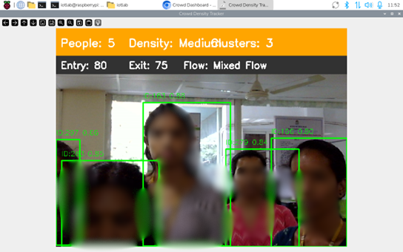
Fig.13: Medium Density Scenario
- People Detected: 5
- Density Level: Medium
- Clusters Identified: 3
- Entry Count: 80
- Exit Count: 75
- Flow Direction: Mixed Flow
- System Status: Moderate crowd (No alert triggered)
Inference:
The crowd size has increased to a moderate level with three clusters formed. Entry is slightly higher than exit, indicating a gradual buildup of people, while movement remains bidirectional without congestion.

Case 3: High Density with Alert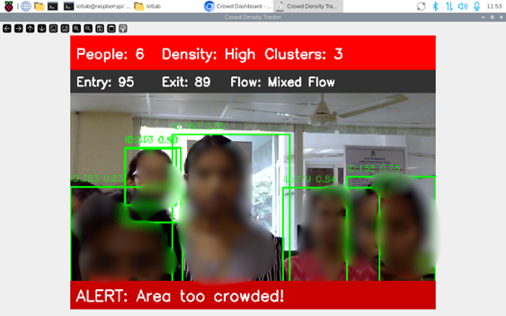
Fig.14: High Density Scenario with alert
- People Detected: 6
- Density Level: High
- Clusters Identified: 3
- Entry Count: 95
- Exit Count: 89
- Flow Direction: Mixed Flow
- Alert Status: Alert Triggered – Area too crowded
Inference:
The crowd density has reached a high level with six people forming three clusters. Entry is greater than exit, indicating crowd accumulation. The system successfully detects overcrowding and triggers an alert, ensuring timely warning for crowd control.

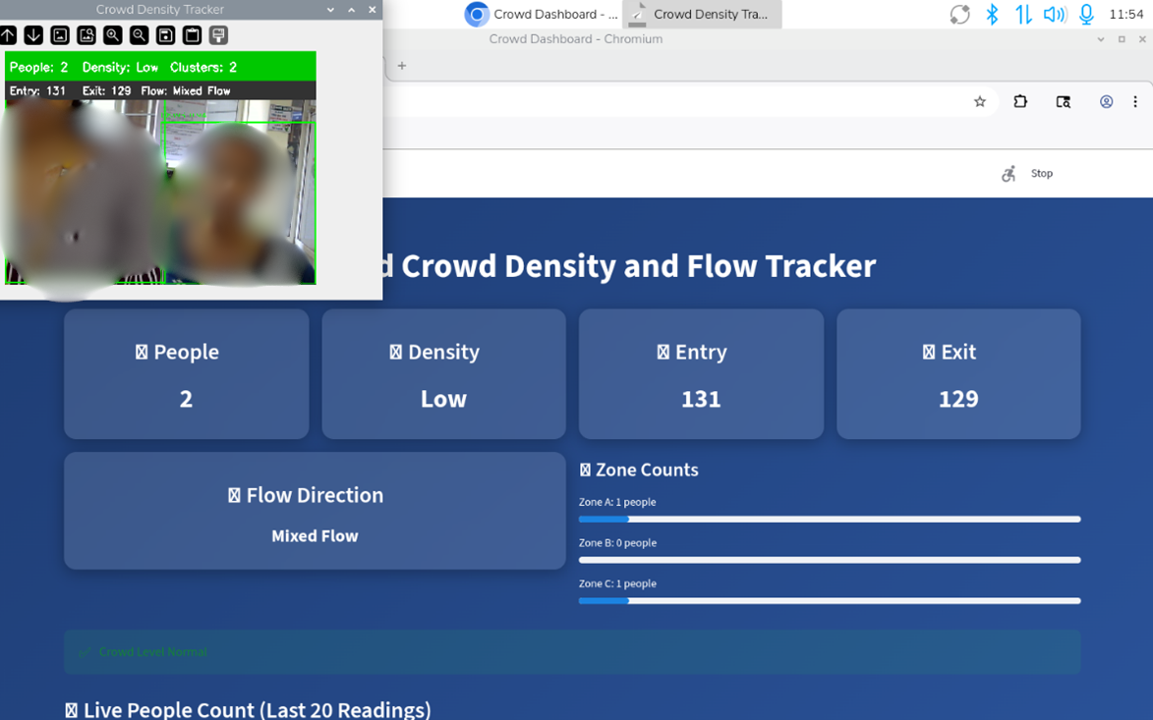
Fig.15: Real-Time Dashboard Integration Showing
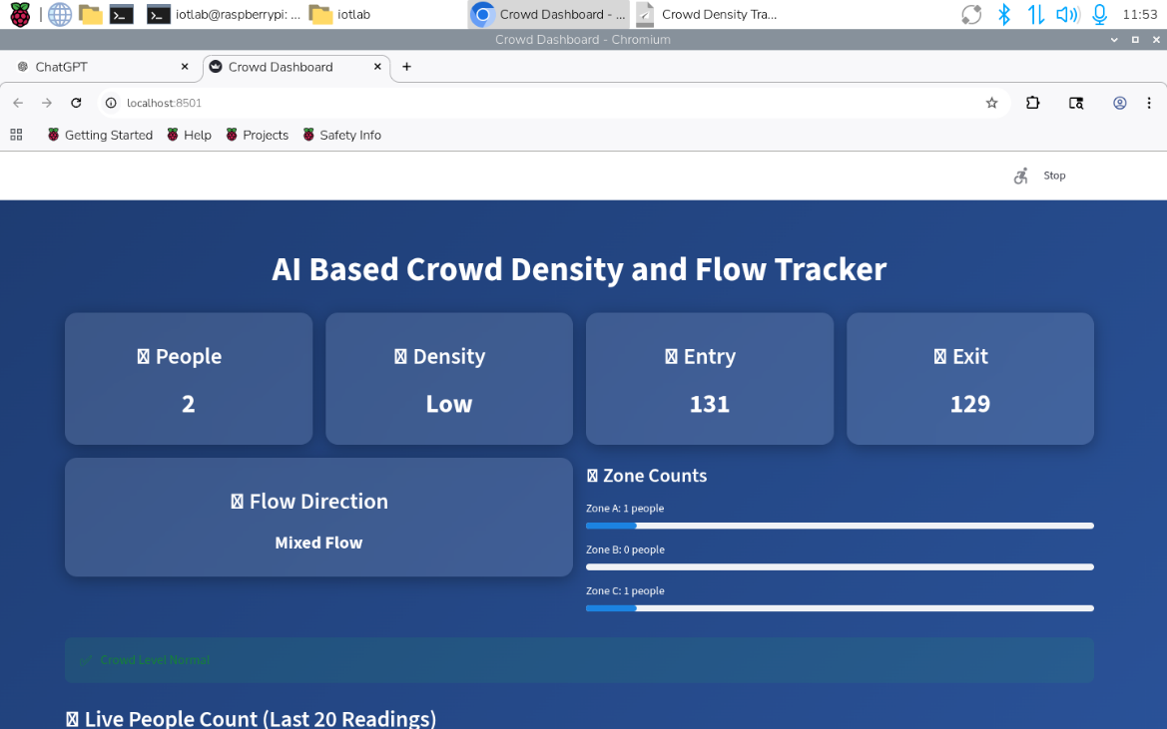
Fig.16: Entry/Exit Statistics, and Zone-wise Distribution

- People Detected: 2
- Density Level: Low
- Entry Count: 131
- Exit Count: 129
- Flow Direction: Mixed Flow
- Zone Distribution:
  - Zone A: 1 person
  - Zone B: 0 people
  - Zone C: 1 person
- System Status: Crowd Level Normal
Inference:
The crowd is minimal and evenly distributed across zones, with nearly equal entry and exit counts indicating stable movement. The system confirms normal conditions with no risk of overcrowding.
These results validate the system’s capability to operate reliably in real-time environments, offering both analytical insights and visual feedback for efficient crowd monitoring and management.

6. Applications
The AI-Based Crowd Density and Flow Tracking system has a wide range of applications across various domains where crowd monitoring and management are essential.
Smart Cities:
In smart city environments, the system can be used to monitor pedestrian movement in real time. The collected data can assist urban planners in designing better infrastructure, optimizing public spaces, and improving traffic management. It also supports data-driven decision-making for efficient city management.
Transportation Hubs:
The system can be deployed in airports, railway stations, and metro stations to manage passenger flow effectively. By monitoring crowd density in real time, authorities can take preventive measures to avoid congestion, improve passenger safety, and enhance overall operational efficiency.
Public Events and Gatherings:
Large-scale events such as concerts, festivals, and rallies often face challenges related to overcrowding. This system can help organizers monitor crowd conditions continuously and take timely actions to prevent dangerous situations. It also enables better planning and crowd control strategies.
Retail Analytics:
In retail environments such as shopping malls and supermarkets, the system can be used to analyze customer movement patterns. This information can help businesses optimize store layouts, improve product placement, and enhance customer experience. It also aids in effective staff allocation based on crowd density.

Public Safety and Surveillance:
The system plays a crucial role in enhancing public safety by detecting high-density zones and potential risks in real time. It can assist security personnel in identifying unusual crowd behavior and responding promptly to emergencies. This reduces the chances of accidents and ensures a safer environment in public spaces.

7. Future Enhancements
The proposed AI-Based Crowd Density and Flow Tracking system can be further enhanced in several ways to improve its performance, scalability, and real-world applicability.
Model Optimization:
Future improvements can focus on enhancing the speed and accuracy of the detection model. By adopting more advanced lightweight deep learning architectures or optimizing existing models, the system can achieve higher frame rates with reduced computational load. Techniques such as pruning, quantization, and knowledge distillation can be explored to make the model more efficient, especially for edge devices like Raspberry Pi.
Multi-Camera Integration:
Currently, the system operates with a single camera input. In future implementations, multiple cameras can be integrated to cover larger areas and eliminate blind spots. This will enable comprehensive monitoring of wide public spaces such as stadiums, malls, and transportation hubs. Multi-camera synchronization and data fusion techniques can be used to provide a unified view of crowd behavior.
Real-Time Alert System:
An advanced alert mechanism can be developed to automatically notify authorities when crowd density exceeds predefined safety thresholds. Alerts can be sent through mobile applications, SMS, or email, ensuring quick response during critical situations. This feature can significantly improve emergency management and reduce the risk of accidents such as stampedes.

Scalability Enhancement:
To support large-scale deployments, the system can be extended using cloud-based infrastructure. Integration with cloud platforms will allow centralized monitoring of multiple locations simultaneously. This will be particularly useful for smart city implementations, where data from various sources can be aggregated and analyzed in real time.
Data Analytics and Insights:
Future work can incorporate advanced data analytics to extract meaningful insights from historical crowd data. By analyzing trends and patterns over time, the system can help in predicting peak hours, identifying high-risk zones, and improving resource allocation. Machine learning models can also be used for predictive analytics to forecast crowd behavior.
System Reliability:
Ensuring continuous and reliable operation is critical for real-world deployment. Future enhancements can focus on improving system robustness by handling varying environmental conditions such as lighting changes, occlusions, and weather variations. Fault tolerance mechanisms and backup systems can also be implemented to ensure uninterrupted monitoring.

8. Conclusion
The AI-Based Crowd Density and Flow Tracker successfully demonstrate an efficient and real-time solution for monitoring crowd behaviour using computer vision and edge computing. By integrating a Raspberry Pi 5 with a webcam and implementing YOLO-based detection, the system accurately detects individuals, estimates crowd density, and analyses movement patterns such as entry, exit, and flow direction. The results show reliable performance in identifying low, medium, and high-density conditions, along with timely alert generation during overcrowding scenarios.
The use of local processing ensures low latency and improved data privacy, while the Streamlit dashboard provides clear and real-time visualization of crowd statistics. Overall, the system offers a cost-effective, scalable, and intelligent approach to crowd monitoring, making it suitable for applications in public safety, smart surveillance, and crowd management systems.

9. References
[1] S. Bhardwaj, A. Dwivedi, A. Pandey, Y. Perwej, and P. R. Khan, “Machine learning-based crowd behavior analysis and forecasting,” 2023.
[2] S. S. Maharajpet and A. V. Hegde, “Intelligent real-time crowd density estimation for proactive event safety: A machine learning approach,” Recent Research Reviews Journal, vol. 4, no. 2, Dec. 2025.
[3] M. Wang, L. Huang, J. Yan, J. Huang, and T. Yang, “A crowd counting and localization network based on adaptive feature fusion and multi-scale global attention up sampling,” IEEE Access, vol. 12, pp. 12919–12939, 2024.
[4] M. Wadhwa, T. Choudhury, G. Raj, and J. C. Patni, “Comparison of yolov8 and detectron2 on crowd counting techniques,” in 2023 7th International Symposium on Innovative Approaches in Smart Technologies (ISAS), 2023, pp. 1–6.
[5] F. Şimşek, “Real-time object detection on Raspberry Pi 5: YOLOv11 vs YOLOv8 under CPU-only constraints,” Medium, 2025.
[6] G. Yiğit, “Crowd detection: Leveraging YOLO for human recognition,” Turkish Journal of Engineering, vol. 9, no. 3, pp. 571–577, July 2025.
[7] SNS Insider, “Crowd analytics market size to hit USD 25.90 billion by 2033, driven by AI-based real-time monitoring and smart city initiatives,” Jan. 12, 2026. [Online]. Available:
[8]hhttps://www.globenewswire.com/news-release/2026/01/12/3216610/0/en/Crowd-Analytics-Market-to-Hit-USD-25-90-Billion-by-2033-Driven-by-AI-Based-Real-Time-Monitoring-and-Smart-City-Initiatives-Research-by-SNS-Insider.html.
[9] “Top 10 best AIoT (Artificial Intelligence & Internet of Things) projects for 2025: Real-world cutting-edge use cases,” Huebits, June 17, 2025. [Online]. Available: https://blog.huebits.in/top-10-best-aiot-artificial-intelligence-internet-of-things-projects-for-2025-real-world-cutting-edge-use-cases/.

